General Capabilities in the Australian Curriculum:
Technologies
The general capabilities play a significant role in the Australian Curriculum in equipping young Australians to live and work successfully in the twenty-first century.
In the Australian Curriculum, capability encompasses knowledge, skills, behaviours and dispositions. Students develop capability when they apply knowledge and skills confidently, effectively and appropriately in complex and changing circumstances, in their learning at school and in their lives outside school.
The Australian Curriculum includes seven general capabilities, as shown in the figure below.
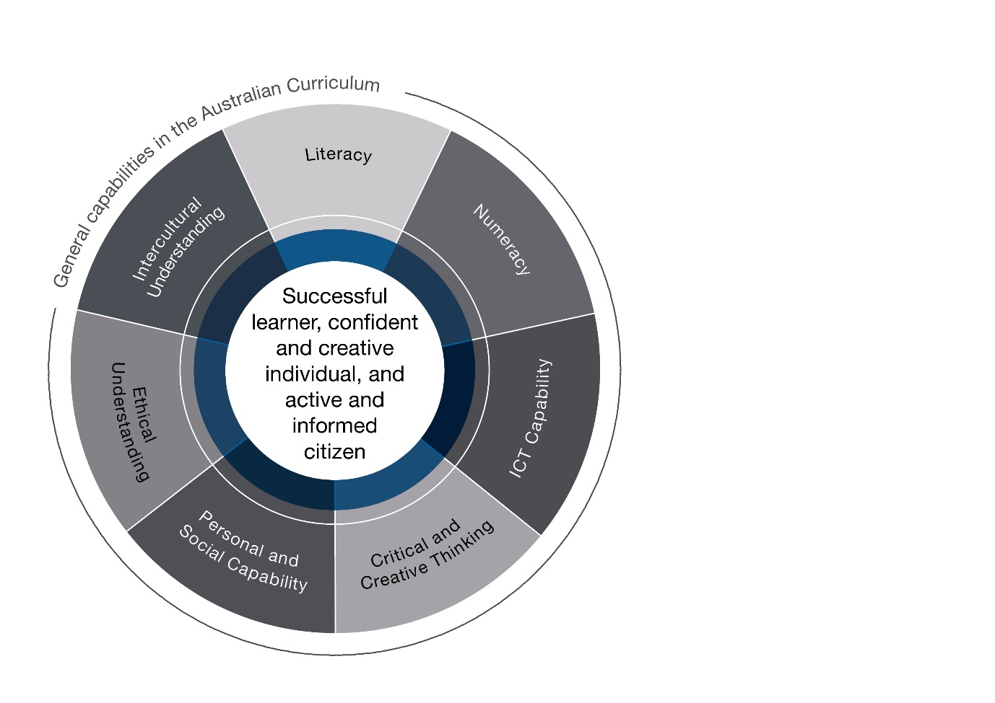

In the Australian Curriculum: Technologies, general capabilities are identified where they are developed or applied in the content descriptions. They are also identified where they offer opportunities to add depth and richness to student learning via the content elaborations, which are provided to give teachers ideas about how they might teach the content. Icons are used to indicate where general capabilities have been identified in learning area content descriptions and elaborations.

Literacy
In the Australian Curriculum: Technologies, students develop literacy as they learn how to communicate ideas, concepts and detailed proposals to a variety of audiences; read and interpret detailed written instructions for specific technologies, often including diagrams and procedural writings such as software user manuals, design briefs, patterns and recipes; prepare accurate, annotated engineering drawings, software instructions and coding; write project outlines, briefs, concept and project management proposals, evaluations, engineering, life cycle and project analysis reports; and prepare detailed specifications for production.
By learning the literacy of technologies, students understand that language varies according to context and they increase their ability to use language flexibly. Technologies vocabulary is often technical and includes specific terms for concepts, processes and production. Students learn to understand that much technological information is presented in the form of drawings, diagrams, flow charts, models, tables and graphs. They also learn the importance of listening, talking and discussing in technologies processes, especially in articulating, questioning and evaluating ideas.

Numeracy
The Australian Curriculum: Technologies gives students opportunities to interpret and use mathematical knowledge and skills in a range of real-life situations. Students use number to calculate, measure and estimate; interpret and draw conclusions from statistics; measure and record throughout the process of generating ideas; develop, refine and test concepts; and cost and sequence when making products and managing projects. In using software, materials, tools and equipment, students work with the concepts of number, geometry, scale, proportion, measurement and volume. They use three-dimensional models, create accurate technical drawings, work with digital models and use computational thinking in decision-making processes when designing and creating best-fit solutions.

Information and Communication Technology (ICT) Capability
In the Australian Curriculum: Digital Technologies, students develop an understanding of the characteristics of data, digital systems, audiences, procedures and computational thinking. They apply this when they investigate, communicate and create digital solutions. Students learn to formulate problems, logically organise and analyse data and represent them in abstract forms. They automate solutions through algorithmic logic. Students decide the best combinations of data, procedures and human and physical resources to generate efficient and effective digital solutions. They create digital solutions that consider economic, environmental and social factors.
In the Australian Curriculum: Design and Technologies, key ICT concepts and skills are strengthened, complemented and extended. Students become familiar with and gain skills using a range of software applications and digital hardware that enable them to realise their design ideas. Students use ICT when they investigate and analyse information and evaluate design ideas and communicate and collaborate online. They develop design ideas; generate plans and diagrams to communicate their designs and produce solutions using digital technologies, for example, creating simulations, drawings and models and manufacturing solutions (from basic drawing programs to computer-aided design/manufacture and rapid prototyping).

Critical and Creative Thinking
In the Australian Curriculum: Technologies, students develop capability in critical and creative thinking as they imagine, generate, develop and critically evaluate ideas. They develop reasoning and the capacity for abstraction through challenging problems that do not have straightforward solutions. Students analyse problems, refine concepts and reflect on the decision-making process by engaging in systems, design and computational thinking. They identify, explore and clarify technologies information and use that knowledge in a range of situations.
Students think critically and creatively about possible, probable and preferred futures. They consider how data, information, systems, materials, tools and equipment (past and present) impact on our lives, and how these elements might be better designed and managed. Experimenting, drawing, modelling, designing and working with digital tools, equipment and software helps students to build their visual and spatial thinking and to create solutions, products, services and environments.

Personal and Social Capability
In the Australian Curriculum: Technologies, students develop personal and social capability as they engage in project management and development in a collaborative workspace. They direct their own learning, plan and carry out investigations, and become independent learners who can apply design thinking, technologies understanding and skills when making decisions. Students develop social and employability skills through working cooperatively in teams, sharing resources and processes, making group decisions, resolving conflict and showing leadership. Designing and innovation involve a degree of risk-taking and as students work with the uncertainty of sharing new ideas they develop resilience.
The Technologies learning area enhances students’ personal and social capability by developing their social awareness. Students develop understanding of diversity by researching and identifying user needs. They consider past and present impacts of decisions on people, communities and environments and develop social responsibility through understanding of, empathy with and respect for others.

Ethical understanding
In the Australian Curriculum: Technologies, students develop the capacity to understand and apply ethical and socially responsible principles when collaborating with others and creating, sharing and using technologies – materials, data, processes, tools and equipment. Using an ethical lens, they investigate past, current and future local, national, regional and global technological priorities. When engaged in systems thinking, students evaluate their findings against the criteria of legality, environmental sustainability, economic viability, health, social and emotional responsibility and social awareness. They explore complex issues associated with technologies and consider possibilities. They are encouraged to develop informed values and attitudes.
Students learn about safe and ethical procedures for investigating and working with people, animals, data and materials. They consider the rights of others and their responsibilities in using sustainable practices that protect the planet and its life forms. They learn to appreciate and value the part they play in the social and natural systems in which they operate.
Students consider their own roles and responsibilities as discerning citizens, and learn to detect bias and inaccuracies. Understanding the protection of data, intellectual property and individual privacy in the school environment helps students to be ethical digital citizens.

Intercultural understanding
In the Australian Curriculum: Technologies, students consider how technologies are used in diverse communities at local, national, regional and global levels, including their impact and potential to transform people’s lives. They explore ways in which past and present practices enable people to use technologies to interact with one another across cultural boundaries. Students investigate how cultural identities and traditions influence the function and form of solutions, products, services and environments designed to meet the needs of daily life now and in the future.
In their interactions with others in online communities, students consider the dynamic and complex nature of cultures, including values, beliefs, practices and assumptions. They recognise and respond to the challenges of cultural diversity by applying appropriate social protocols. Students learn about the interactions between technologies and society and take responsibility for securing positive outcomes for members of all cultural groups including those faced with prejudice and misunderstanding.

